**EXCEPTION HANDLING**

**Introduction**

* **Exception:** Anything that **disrupts** normal flow of program.

**Importing Exception Handling Class**



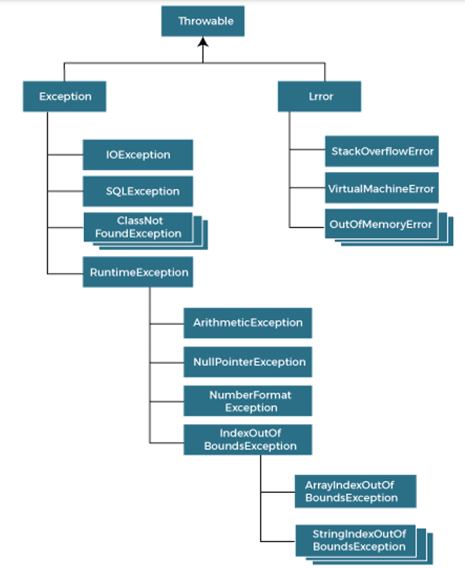

* **DivisionByZeroException** is an **ArithmeticException**.

**Types of Exception Handling**

* **Checked exception:**
  + Present in Throwable.
  + **ClassNotFoundException**, **IOException**, **SQLException**.
  + Are checked at compile time.
* **Unchecked exception:**
  + Not present in Throwable.
  + **RuntimeException**
  + Are checked at runtime.
* **Error:**
  + Nothing can be done about it.
  + All errors.

**Java Exception Keywords**

* ***try***, ***catch***, ***finally***, ***throw***, ***throws***
* ***finally*** is used for executing codes under it whether exceptions are handled or not.
* ***finally*** keyword seems unnecessary to use.

**try-catch Example**

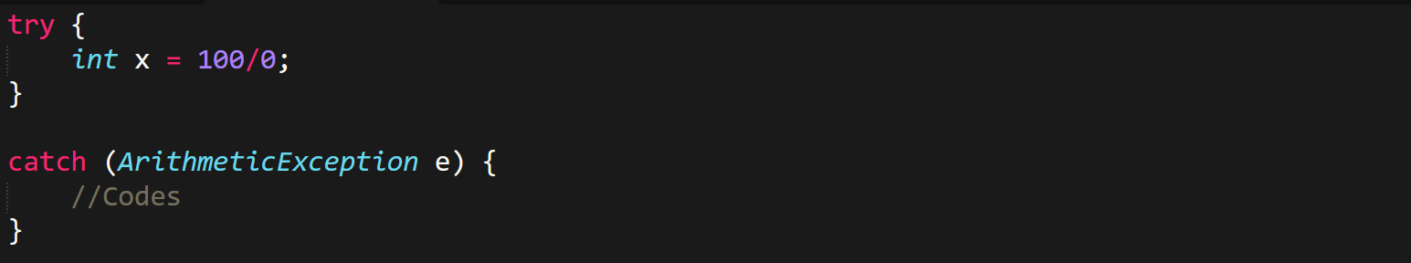

**Scenarios for Exceptions**

* **NullPointerException:** Performing operation on a **null** variable.
* **NumberFormatException:** Using numerical functions on a different data type.

**Difference Between throw And throws**

* ***throw* example:**

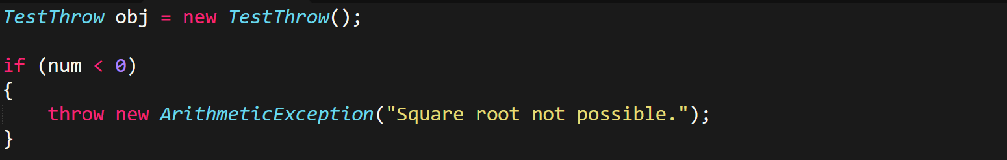

* ***throws* example:**

